Automated SaaS Access Validation
& Provisioning System
Built with n8n • Elsevier SciVal • Workflow Automation

Executive Summary

This project delivers an end-to-end automation system built in n8n that streamlines SaaS access validation and provisioning for Elsevier's SciVal platform. The system eliminates manual review bottlenecks by applying rule-based logic to evaluate access requests in real time — automatically approving, rejecting, or escalating based on module limits, product dependencies, and entitlement rules.

The result is a faster, more consistent provisioning process that reduces human error, accelerates time-to-access for customers, and enforces entitlement policies at scale.

Problem Statement

Prior to this automation, SciVal access requests were handled manually, creating the following pain points:

- Slow turnaround times for access approvals, delaying customer onboarding
- Inconsistent enforcement of module limits and product dependency rules
- High volume of repetitive validation work consuming internal team bandwidth
- Risk of incorrect access setup due to human error in rule interpretation

Solution Overview

The automation system intercepts incoming access requests and routes them through a structured validation pipeline. Each request is evaluated against a defined ruleset before any provisioning action is taken.

Validation Logic

- Module limit checks — verifies the requested module does not exceed the account's entitlement tier
- Product dependency validation — ensures prerequisite products are active before granting access
- Access rule enforcement — applies business rules specific to SciVal's access control matrix

Outcome Routing

- Approved — access is provisioned and a confirmation email is dispatched automatically
- Rejected — request is declined with a precise, rule-specific rejection reason communicated to the requester

Key Features

Feature | Description
Rule-Based Validation Engine | Structured decision logic evaluates each request against predefined access and entitlement rules.
Conditional Workflow Routing | IF/ELSE branching directs requests to the correct approval or rejection path automatically.
Dynamic Message Generation | Personalised confirmation and rejection emails are generated with context-specific messaging.
Automated Email Triggering | Gmail integration sends notifications immediately upon validation outcome — no manual step required.
Error Handling & Status Tracking | Built-in error nodes capture exceptions and surface validation status at each workflow stage.

Technology Stack

n8n | JSON Logic | Gmail API | Workflow Automation

The system is built entirely on n8n's low-code automation platform, leveraging native nodes for conditional logic, expression evaluation, and email delivery. No external infrastructure is required — the workflow is self-contained and portable.

Workflow Screenshots

The following screenshots illustrate the n8n workflow in action — from the top-level overview to individual validation nodes and conditional routing logic.

Workflow Overview
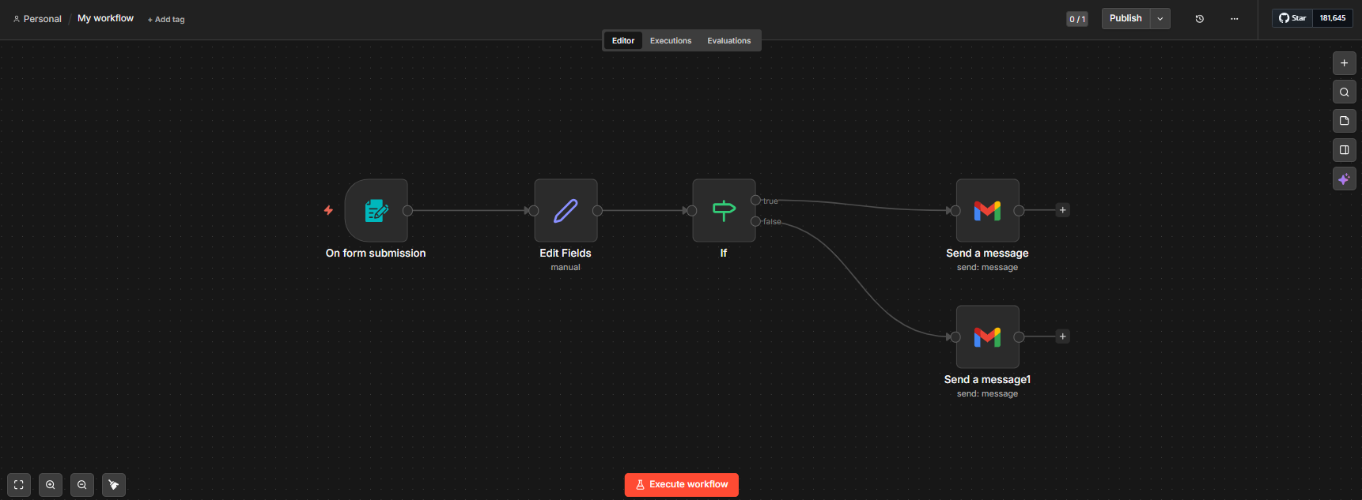
Figure 1: Top-level n8n workflow — access request intake and routing

Full Workflow Detail
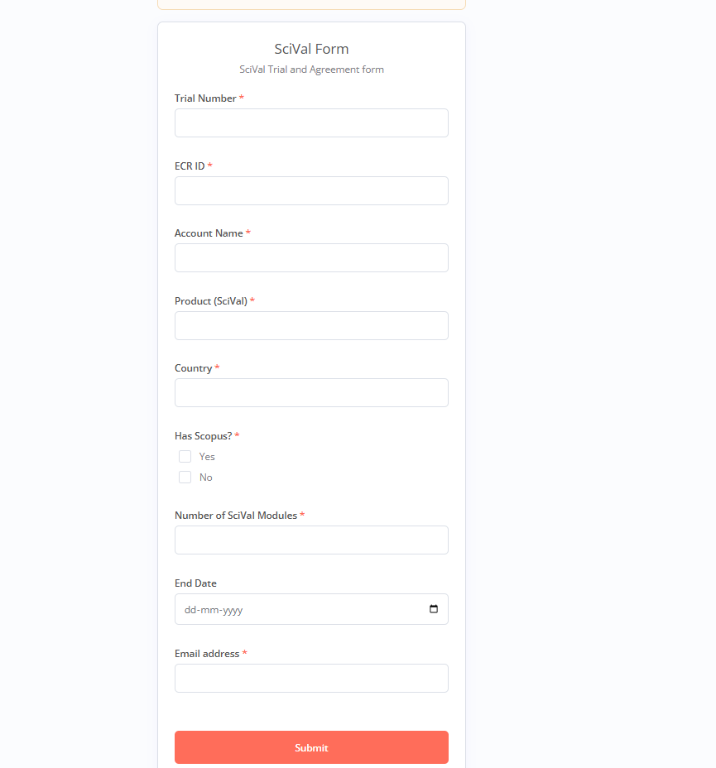
Figure 2: Complete workflow with all validation nodes and conditional branches

Validation & Routing Nodes
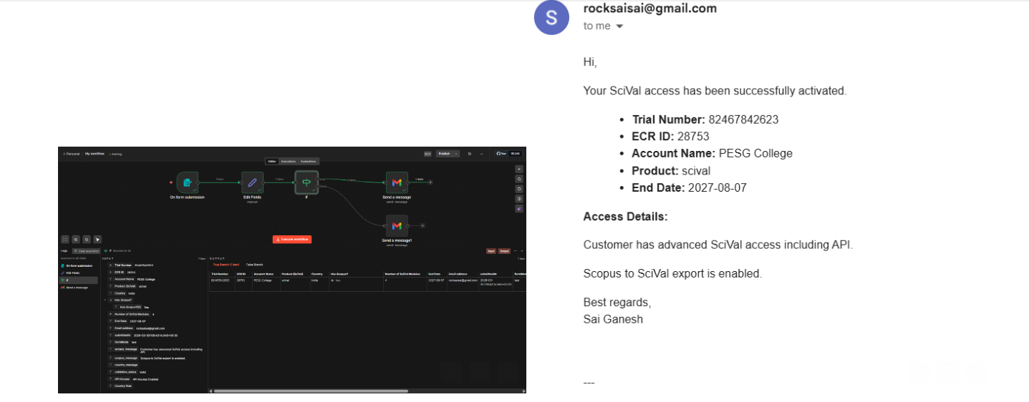
Figure 3: Module limit and product dependency validation logic
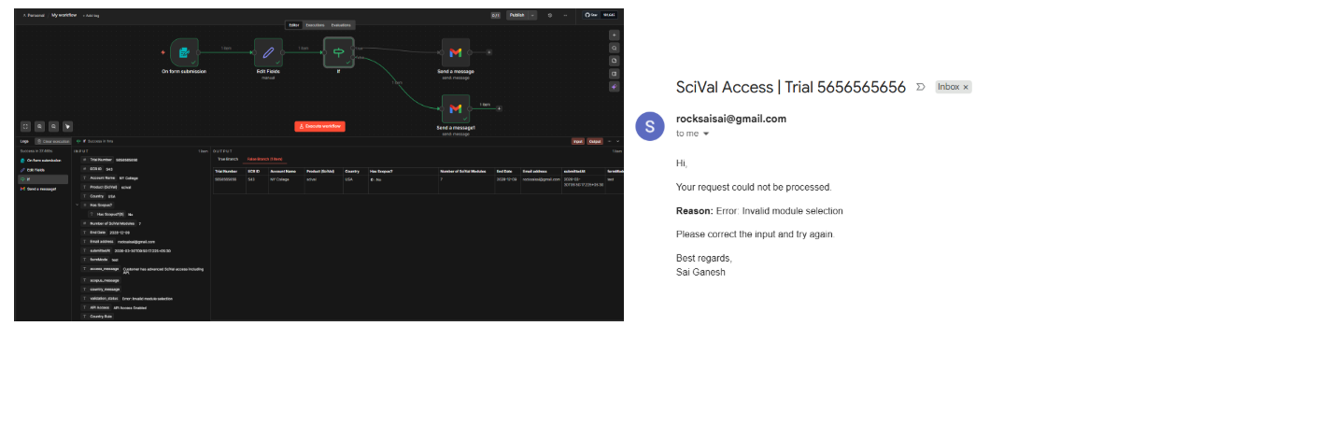
Figure 4: Conditional routing — approval vs rejection path
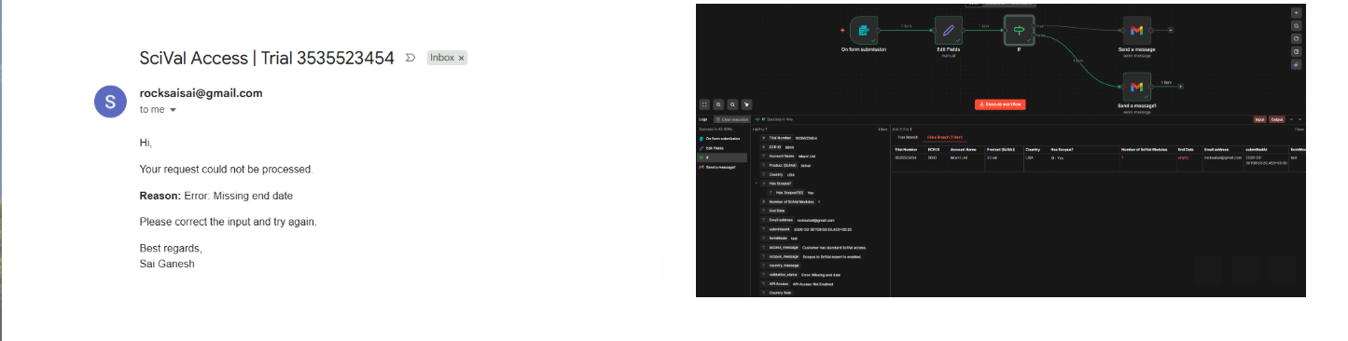
Figure 5: Access rule enforcement node

Email Notification Nodes
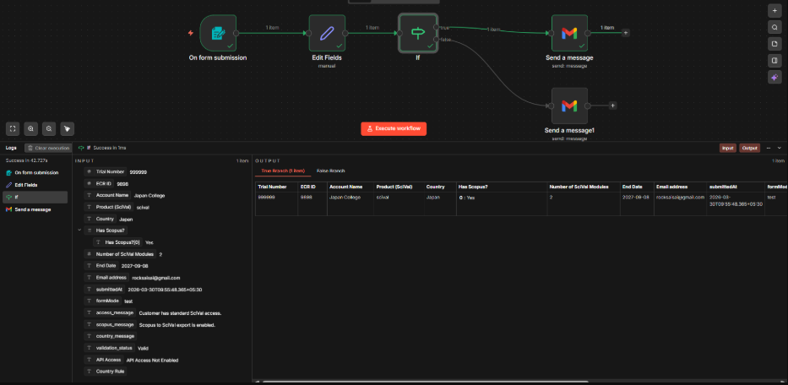
Figure 6: Approval confirmation email trigger
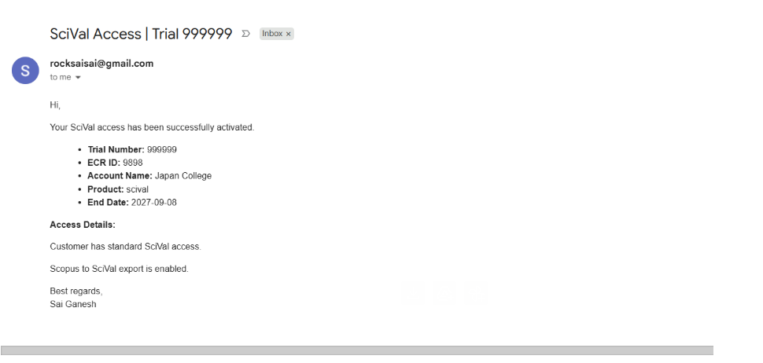
Figure 7: Rejection email with dynamic reason generation

Business Impact

- Eliminates manual validation effort for routine access requests
- Reduces provisioning errors through consistent rule enforcement
- Accelerates customer time-to-access by removing human handoff delays
- Scales to handle increased request volume without additional headcount
- Creates an auditable, repeatable process for access governance

Skills Demonstrated

This project showcases applied skills directly relevant to GTM automation and revenue operations roles:

- Workflow automation design and implementation (n8n)
- Business rule translation into executable conditional logic
- API and email system integration
- End-to-end process thinking from request intake to outcome delivery
- SaaS entitlement and access control domain knowledge (Elsevier SciVal)

Built at Elsevier • SciVal Platform Team

